Project Screenshots
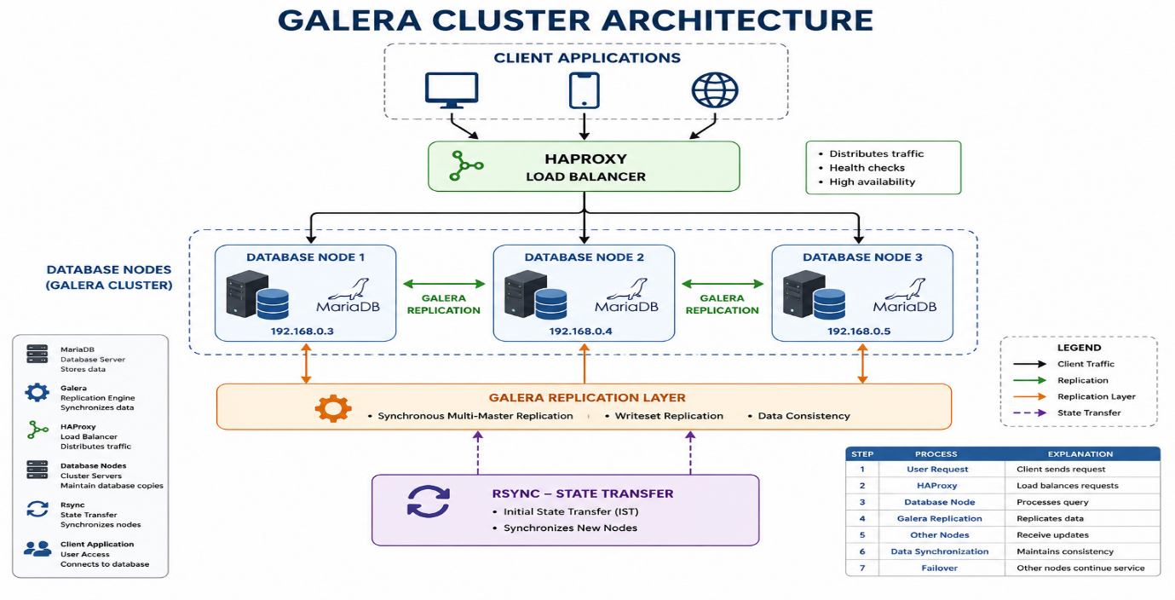Figure: Galera Cluster Architecture
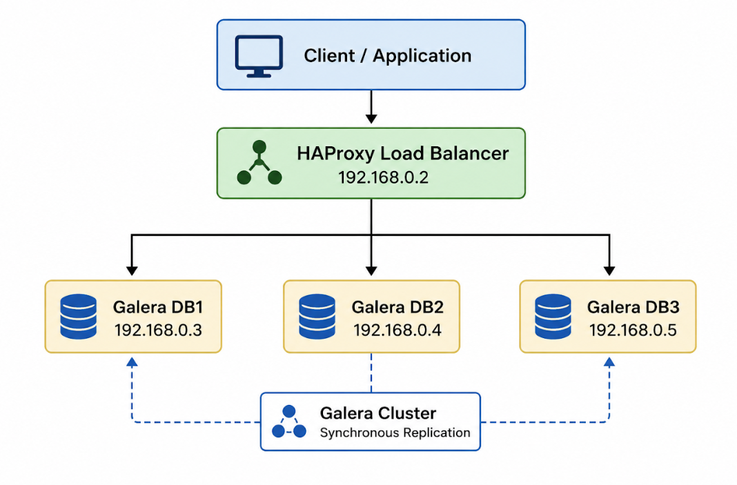Figure: Project Architecture
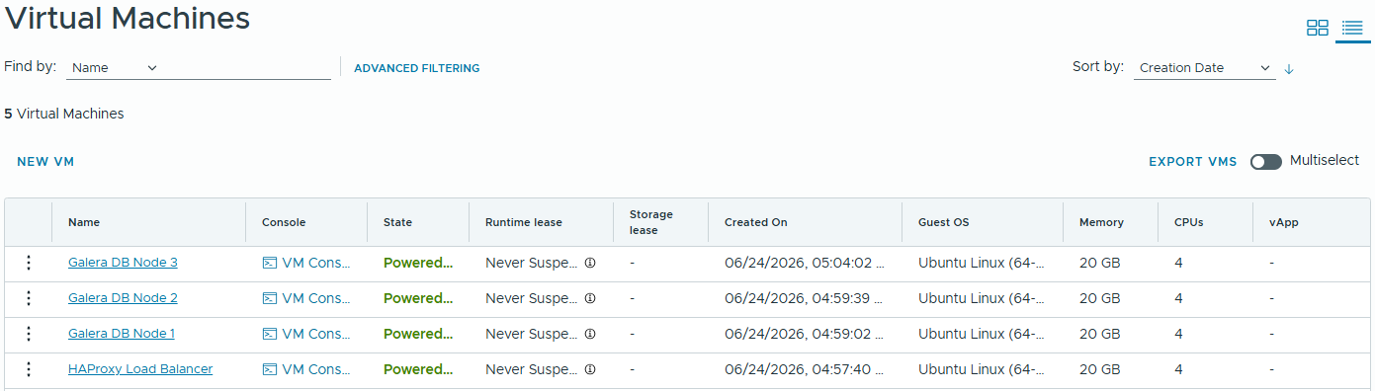Figure: VM Creation
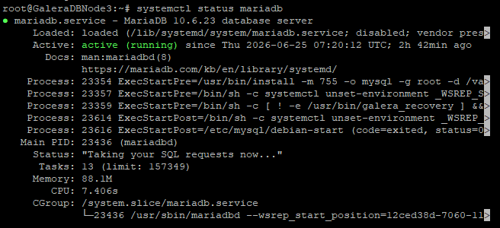Figure: MariaDB Installed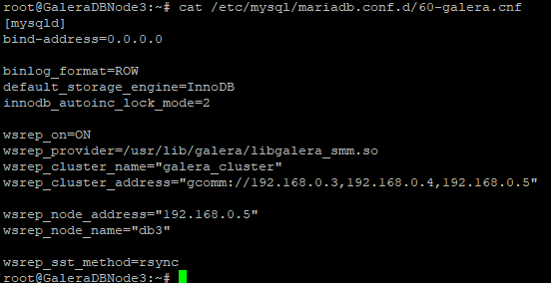Figure: Galera Configuration
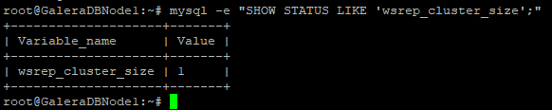Figure: Verify Cluster Size
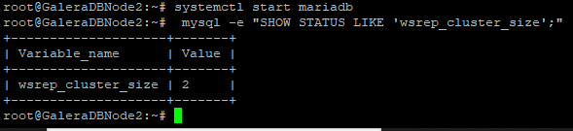 Figure: Join DB2 to Cluster
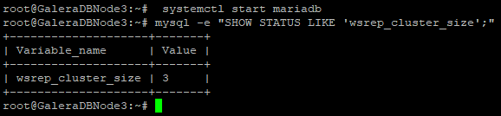Figure: Join DB3 to Cluster
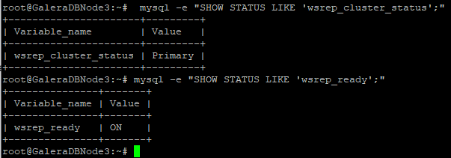Figure: Verify Cluster Status
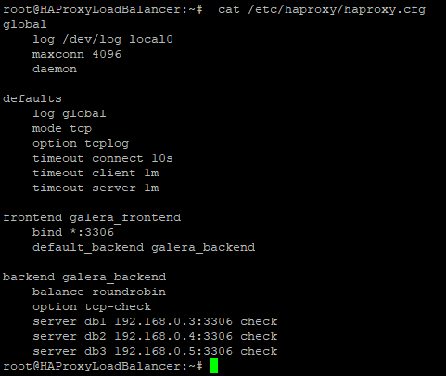Figure: Configure HAProxy
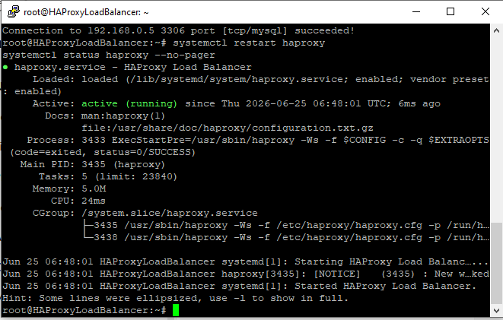Figure: Start HAProxy
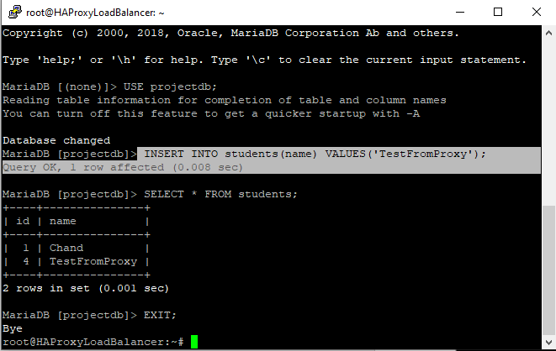
Figure: Create Test Database
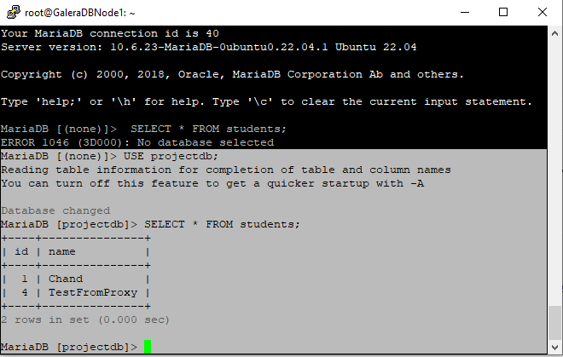
Figure: Verify Replication
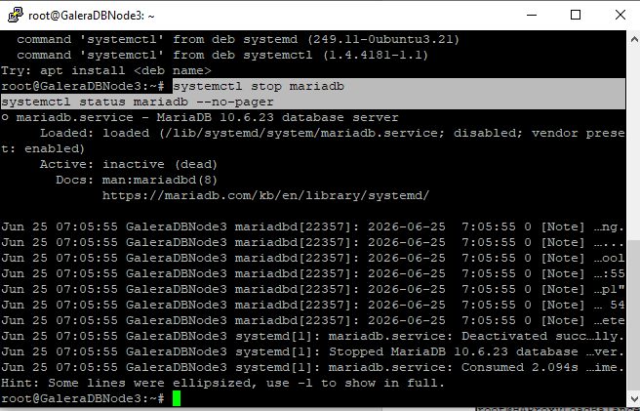
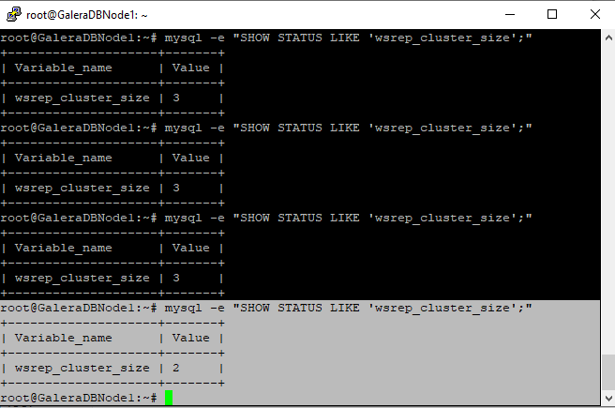Figure: Failover Testing
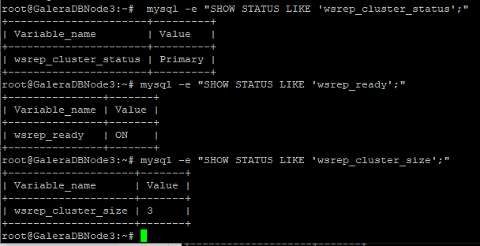
Figure: Recover Failed Node

